**QUICK START TO JAVASCRIPT: VOLUME 1**

**Quick start to javascipt: volume 1**

* what is javascript?

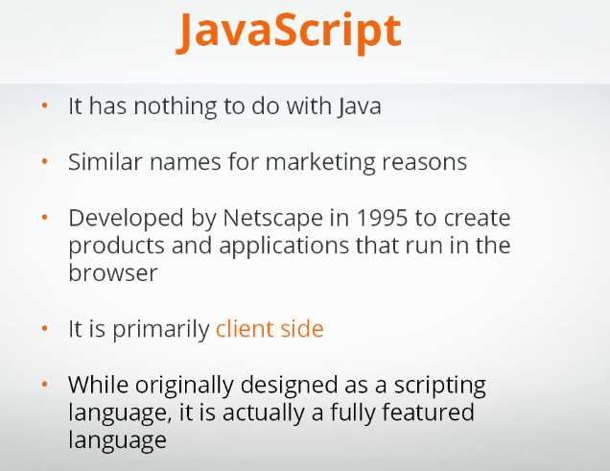

* hello world: writing your first javascript
* Introduction operators
* Understanding the console
* String, number and Boolean values

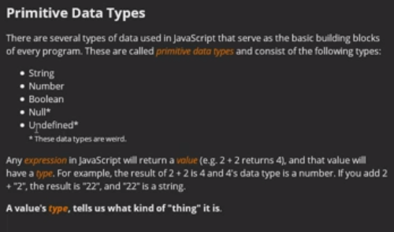

* Variables

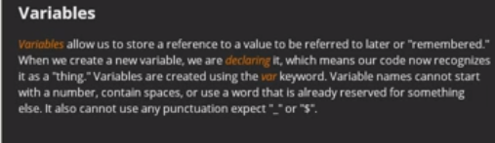

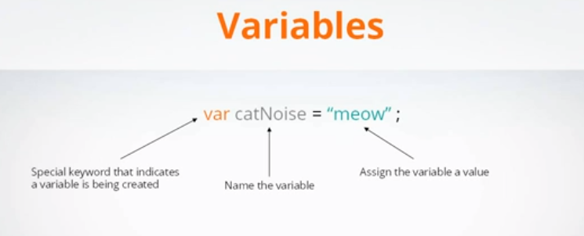

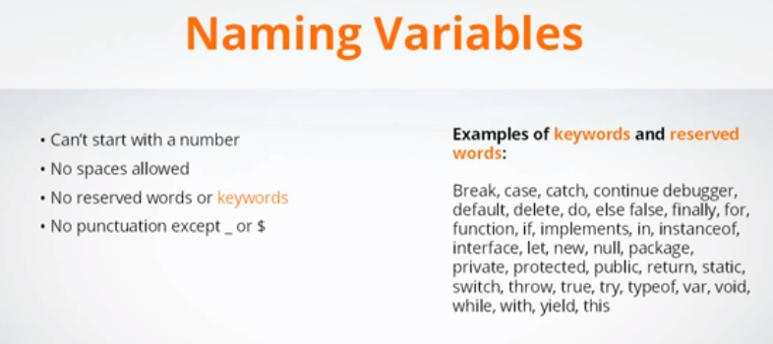

* Using variables
* Introduction to control flow if/else statements

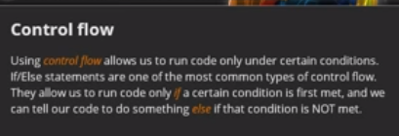

* Using else/if

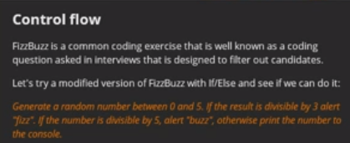

* Control flow and comparison operators
* Putting it all together: zombie text adventure game

